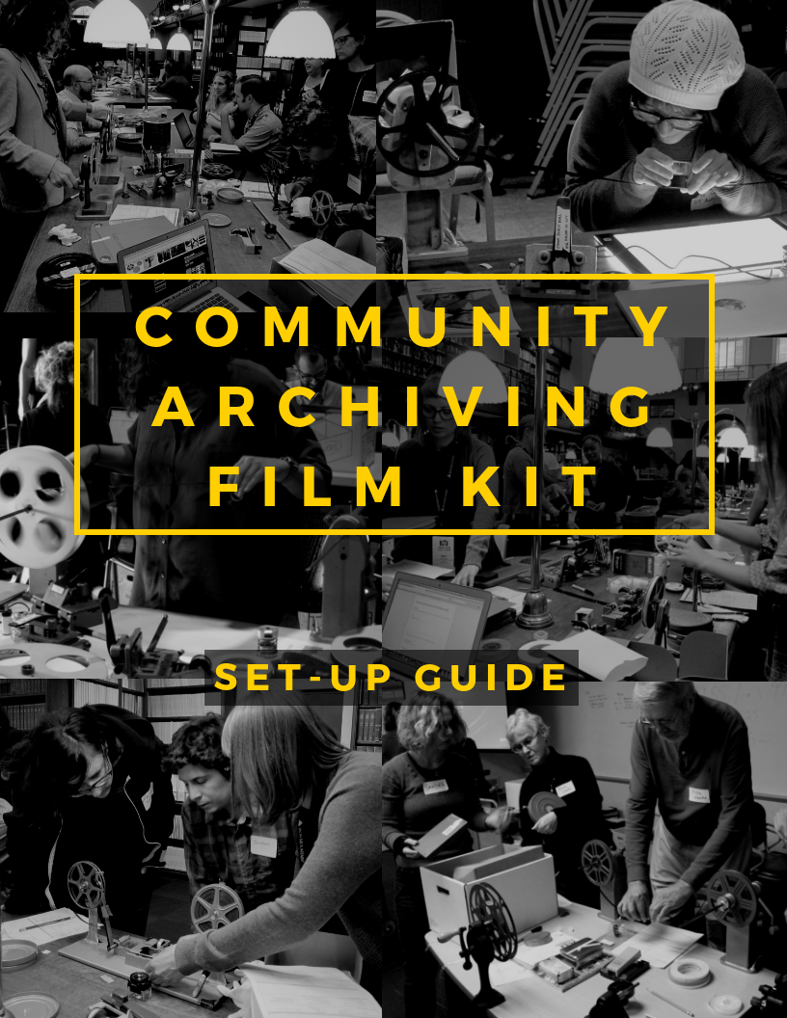

[ Purpose of the kit ]

This portable kit was born of the Community Archiving Workshops. The goal of these workshops is to help an organization jump-start the preservation of an audiovisual collection—film, video, or audio. The idea is simple: experienced audiovisual archivists partner with local volunteers for a daylong workshop that will assess and catalog as many materials as possible, and in the process, provide hands-on training for local volunteers, so they can carry on the work in the future. The model used thus far is for pairs––one moving image archivist and one community volunteer––to work together. With proper planning, these workshops are not only extremely valuable to your community’s organization—they are also a lot of fun. We hope this handbook will empower you to hold a workshop of your own.

Visit the Community Archiving Workshop Flickr page to see photos of past workshop activity.

Acknowledgements

Planning Organizations
Association of Moving Image Archivists (AMIA)
AMIA – Independent Media Committee
AMIA – Diversity Committee

CAW Committee Members
Rachel E. Beattie, Toronto, Canada
Kelli Hix, Nashville, TN
Mona Jimenez, New York, NY
Marie Lascu, New York, NY
Jeff Martin, Chicago, IL
Yvonne Ng, Prague, Czech Republic
Amy Sloper, Cambridge, MA
Moriah Ulinskas, Oakland, CA
Pamela Vadakan, San Francisco, CA
Sandra Yates, Houston, TX

[ Unpacking the kit ]

Open the kit!
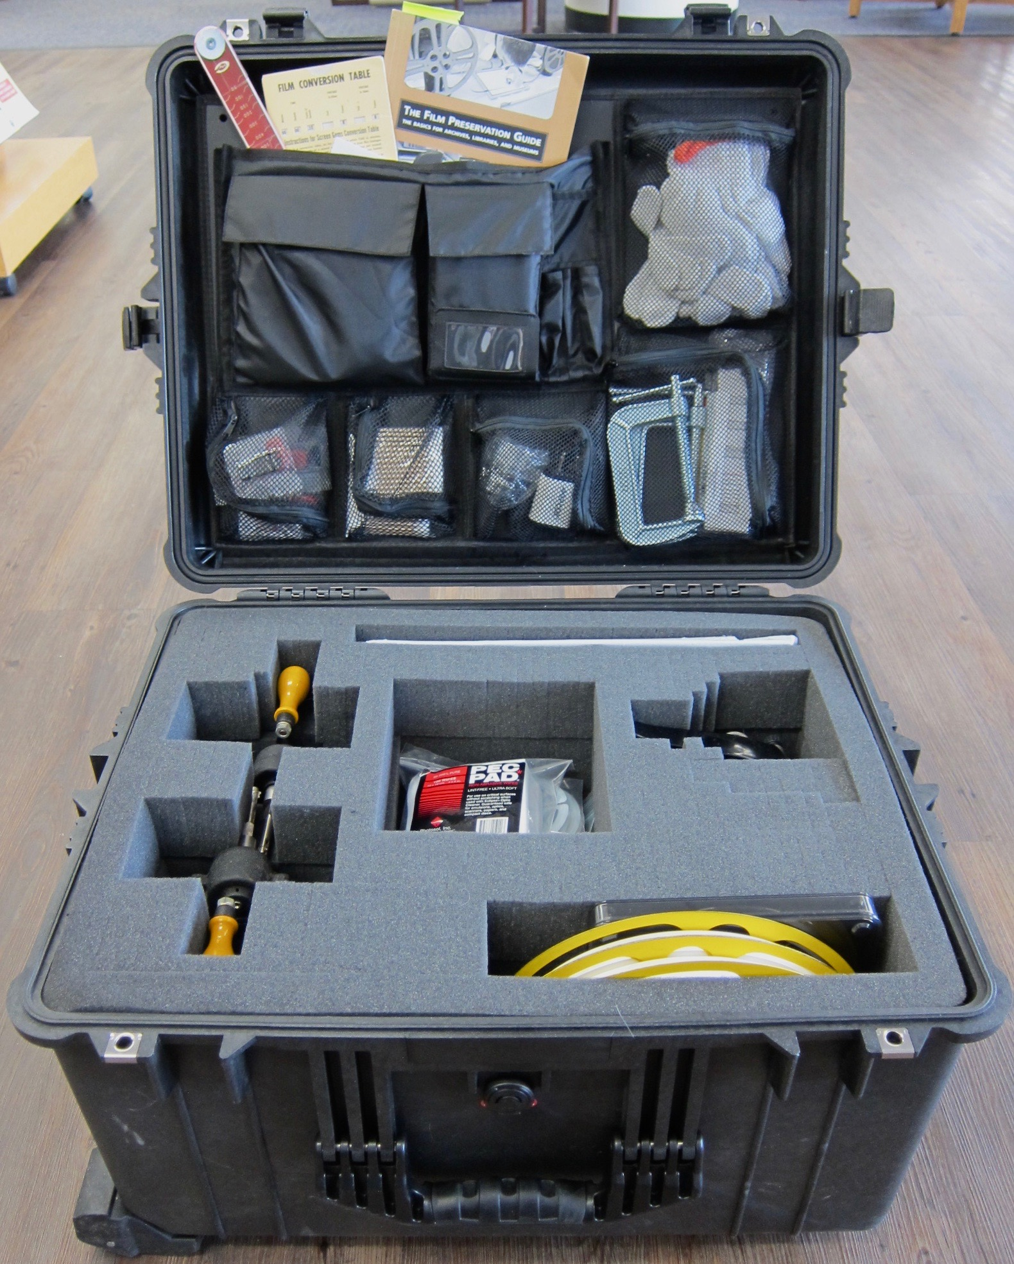

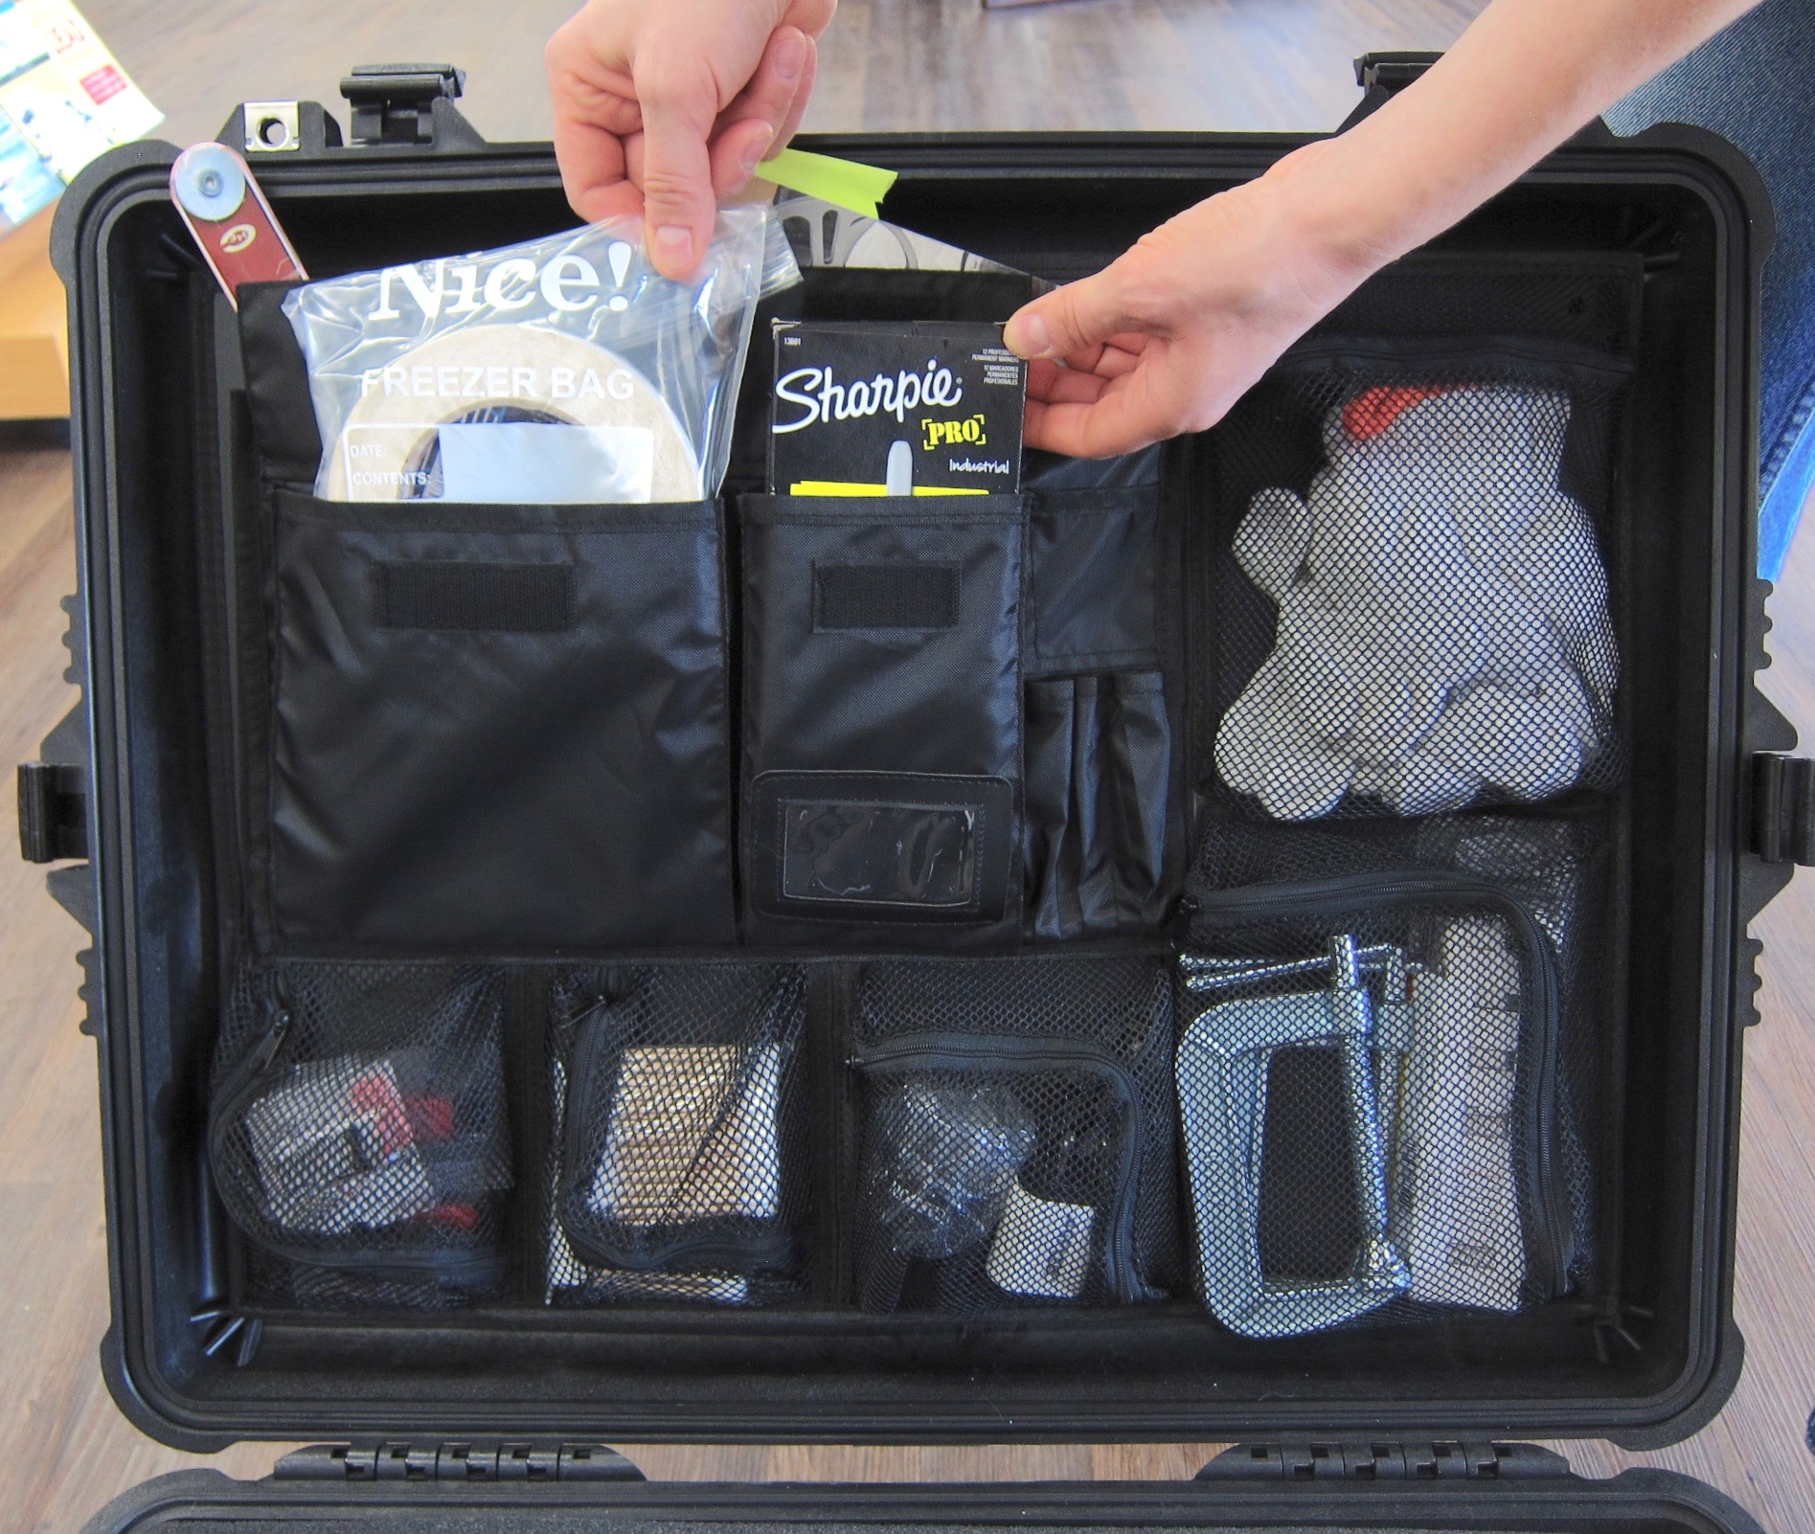

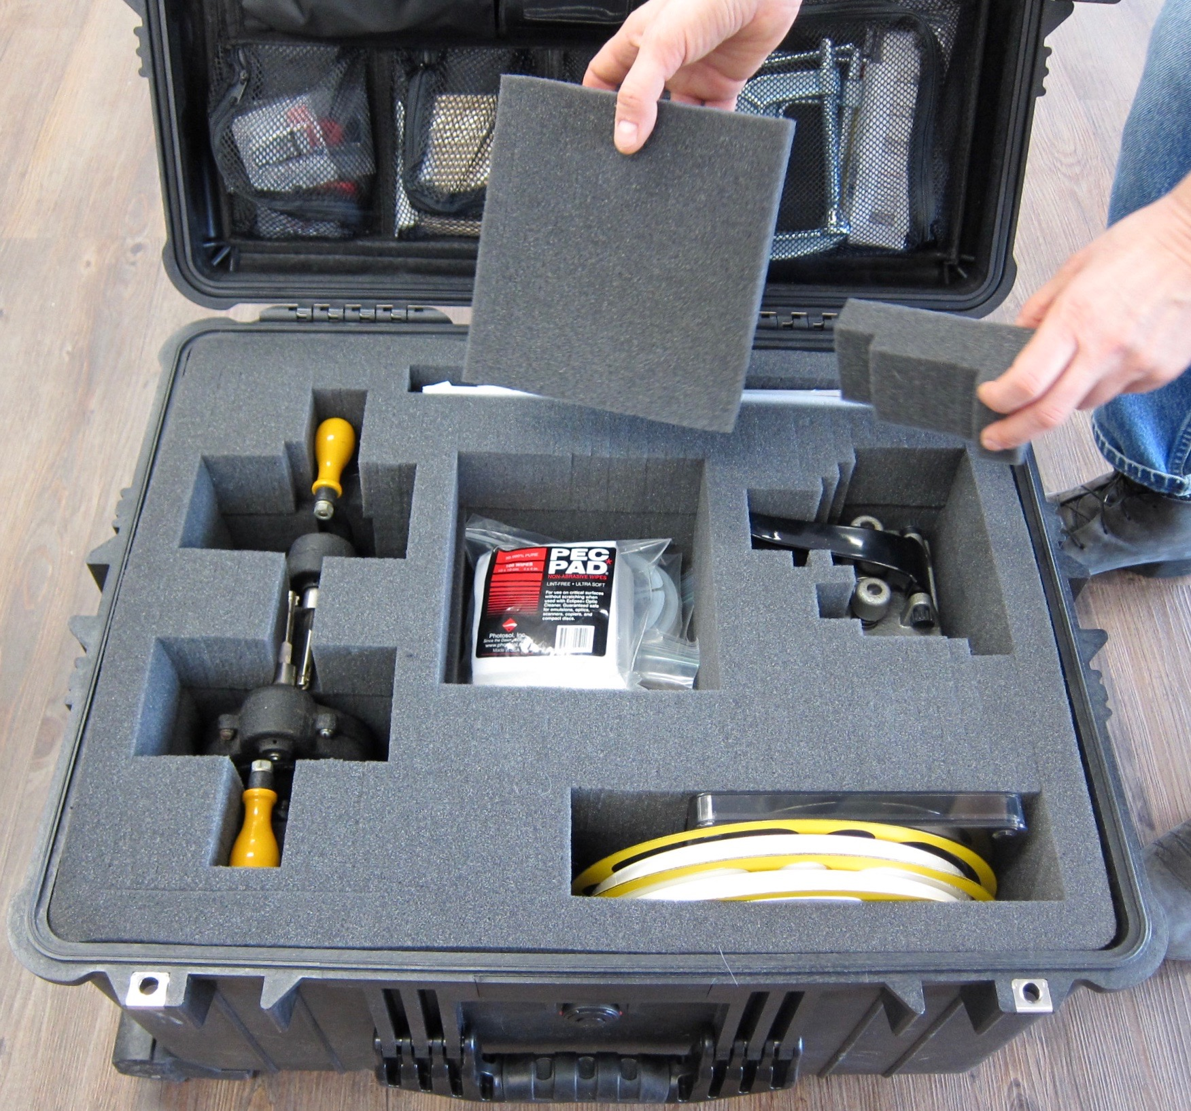

There are two pieces of removable foam covering compartments in the base, but the rest of the foam should stay in place.

[ Top compartment inventory ]

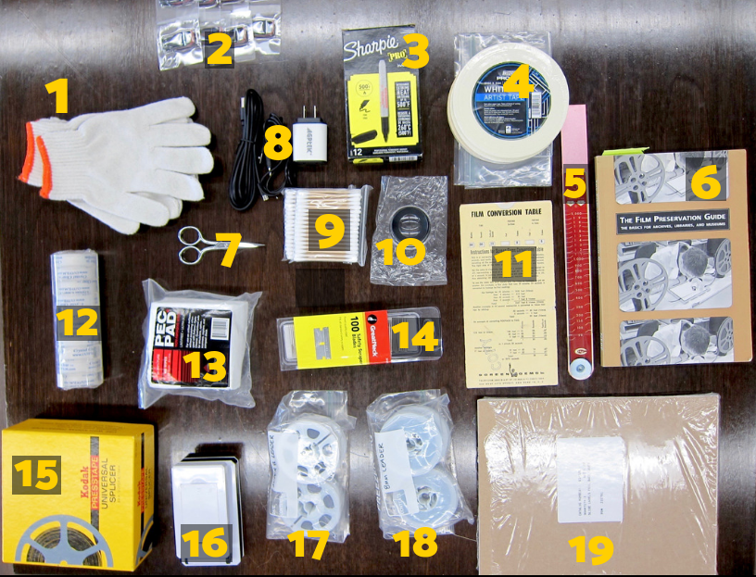

- Cotton gloves
- 8GB USB drives
- Sharpies for labeling film
- Tape for the film ends
- Film footage ruler
- The Film Preservation Guide book
- Scissors
- Adapters for the lamp and desk light
- Q-Tips
- Magnifying glass
- Film length to runtime converter
- 16mm film splicing tape
- Film cleaning pads
- Razor blades
- 8mm/super 8 presstape splicer
- Desktop lamp
- Super 8 leader
- 8mm leader
- Adhesive labels for film cans or videotapes

[ Bottom compartment inventory ]
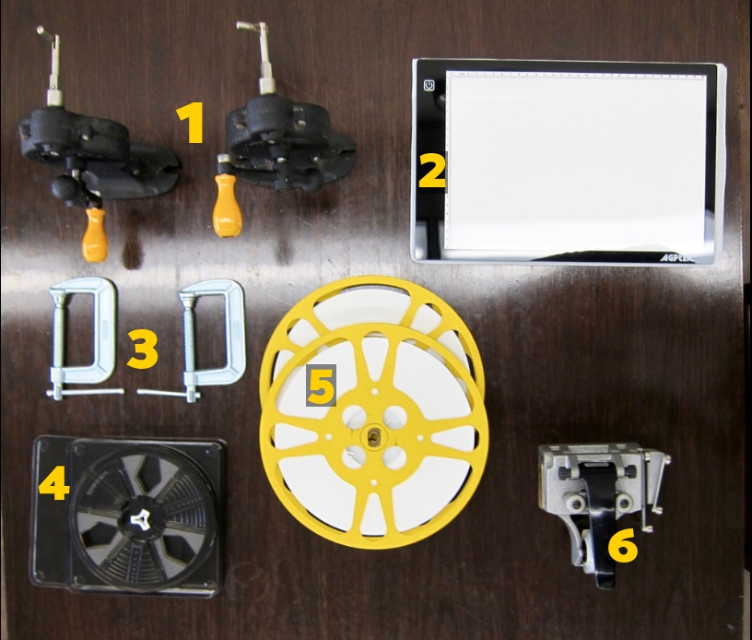

- Film rewind set
- USB powered light table
- C-clamps
- 8mm/super 8 reel
- 16mm film leader & 16mm split reels
- 16mm film splicer

[ Setting it up ]

Firmly attach the rewinder bases to a table using the C-clamps:
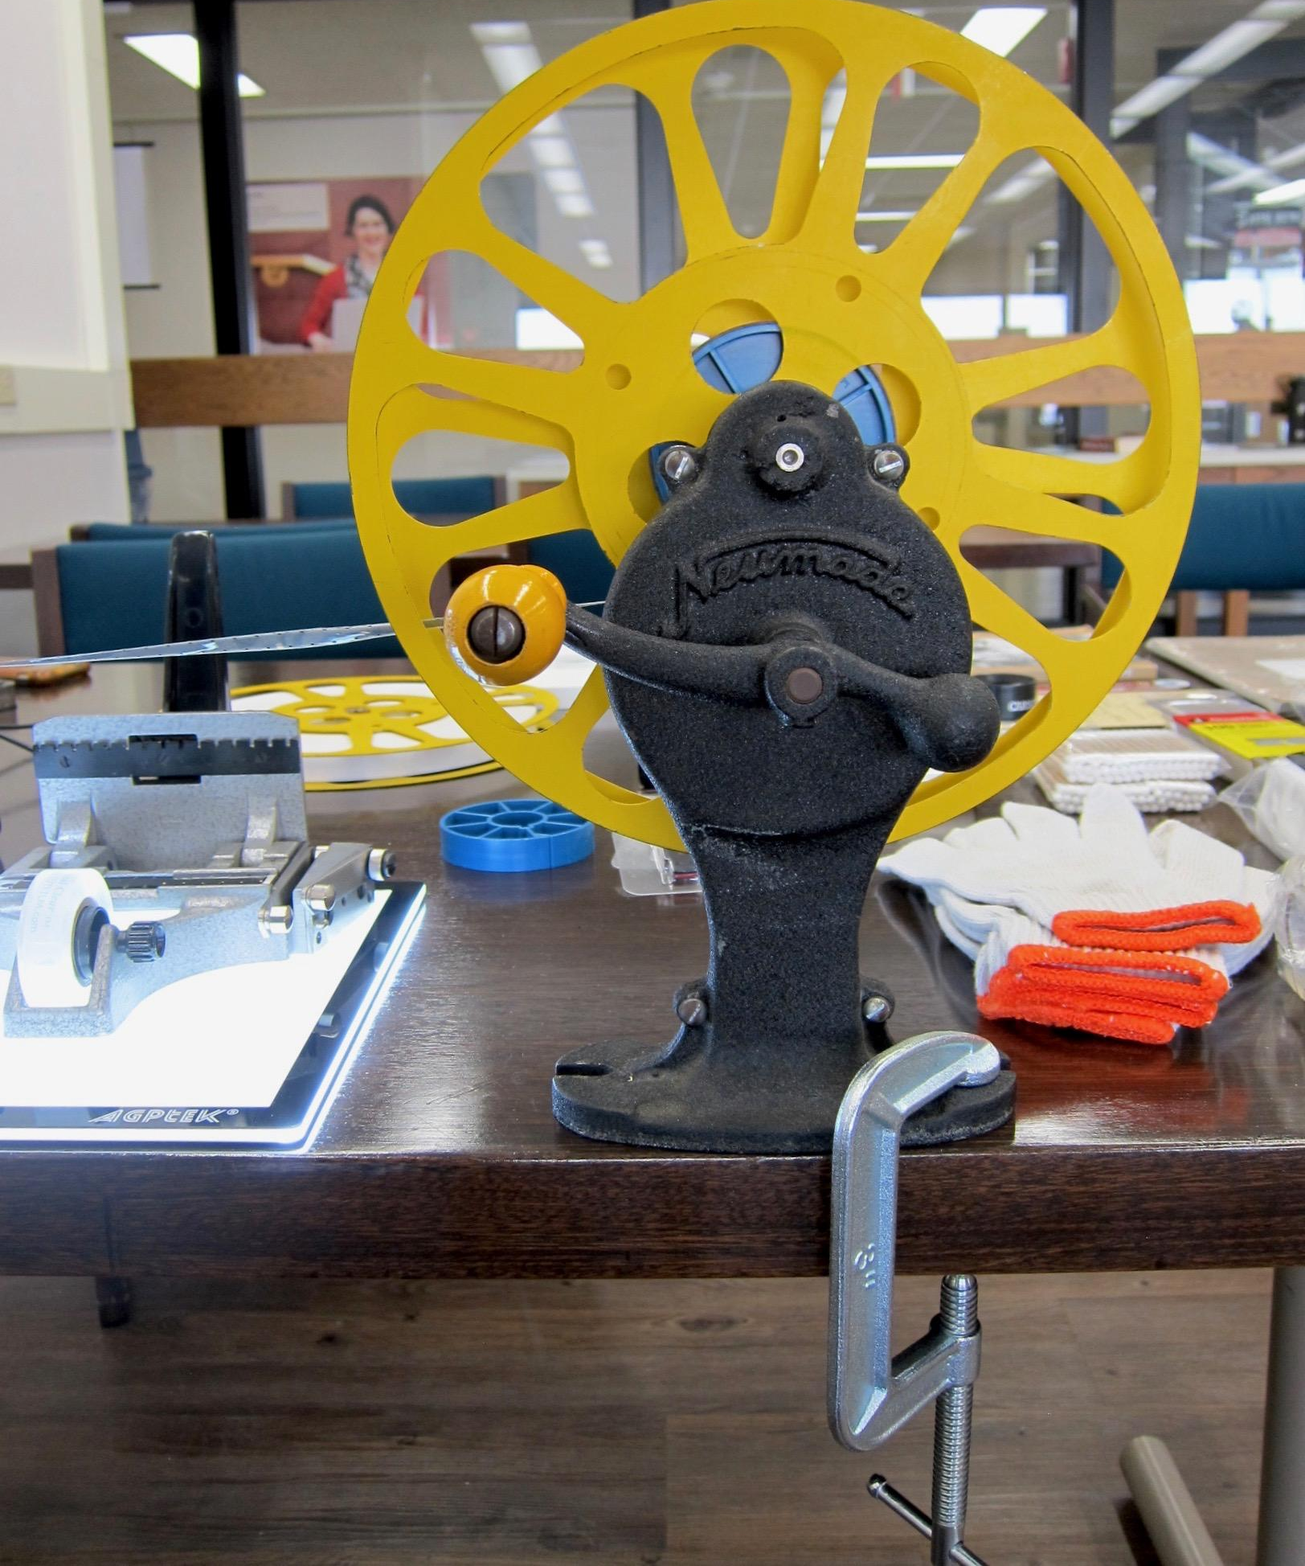
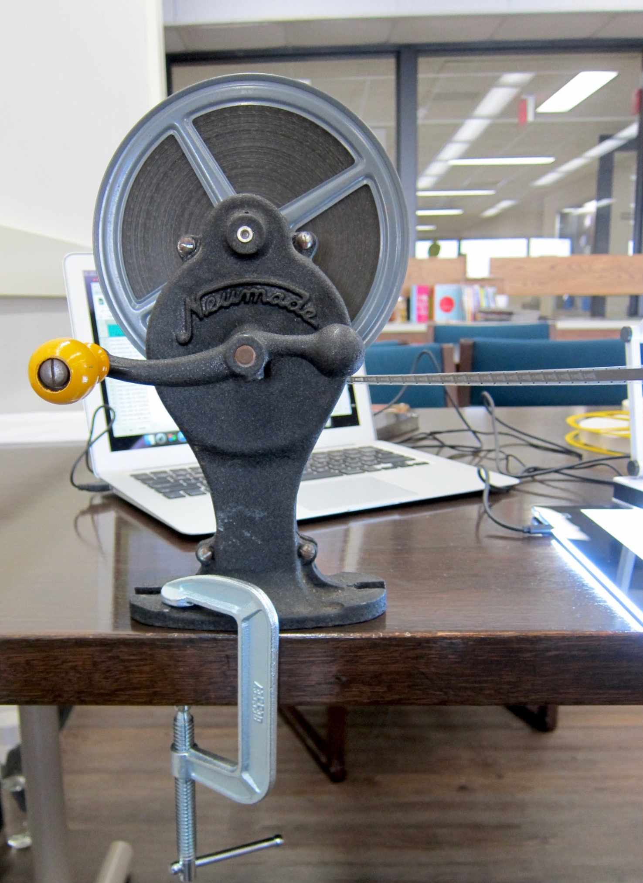

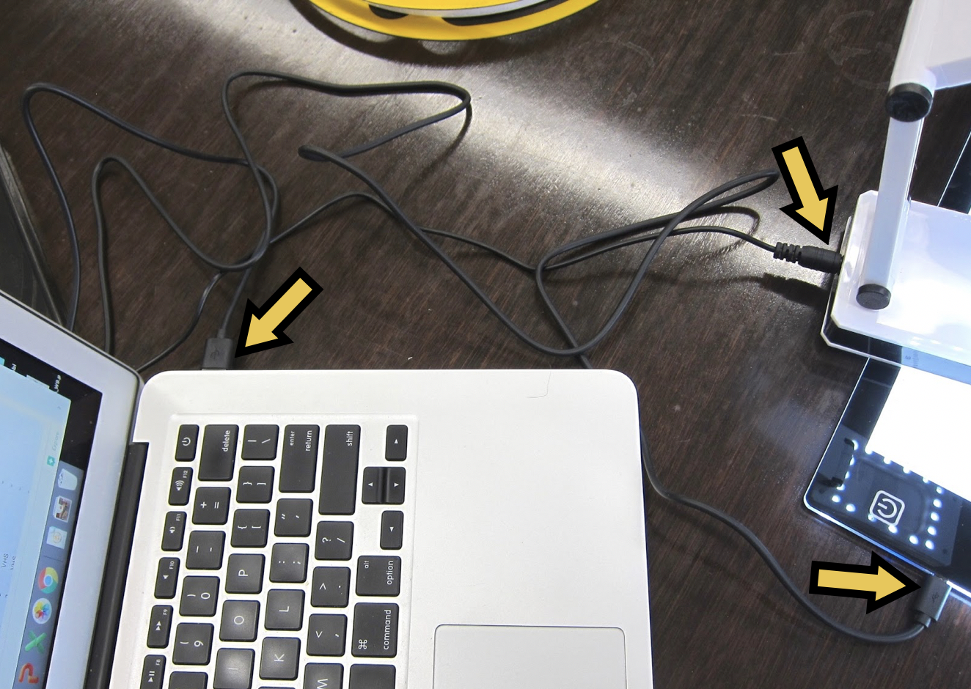

You can plug the light pad and the pop-up light into a laptop using the USB drive or using the power adapter

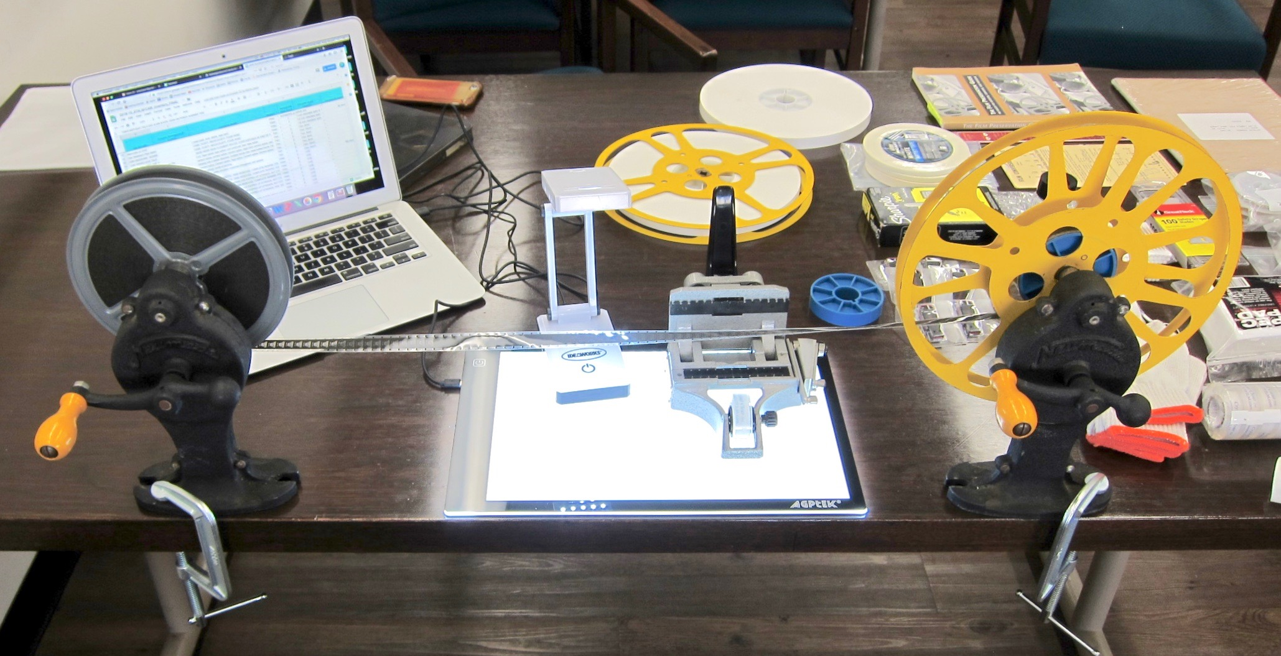

[ Shipping & Contact ]

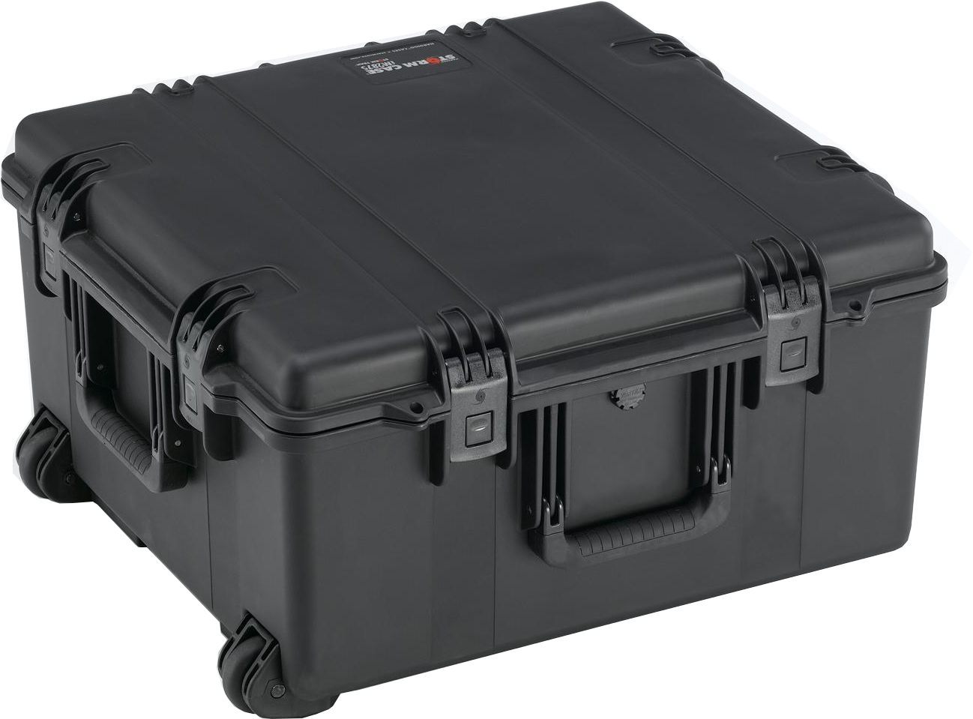
Dimensions of the case: 25x19x14”

Weight: 75 lbs

Person of contact: [Contact Name]
[Contact Title and Organization]
[Contact email, phone (optional)]

